**Main Menu**

When the console application is started, menu displaying possible choices is shown

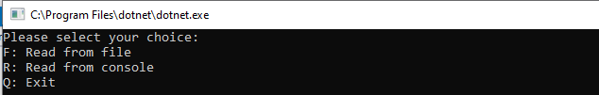

**First Choice: F**

When key F is chosen, user is prompted to specify the path of the file for inputs

Sample file

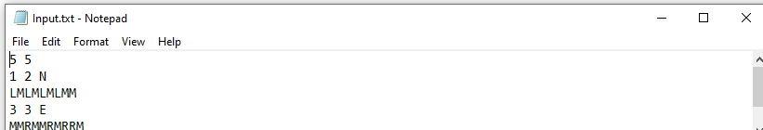

The first line of input is the upper-right coordinates of the plateau, the lower-left coordinates are assumed to be 0,0.

The rest of the input is information pertaining to the rovers that have been deployed. Each rover

has two lines of input. The first line gives the rover's position, and the second line is a series of

instructions telling the rover how to explore the plateau.

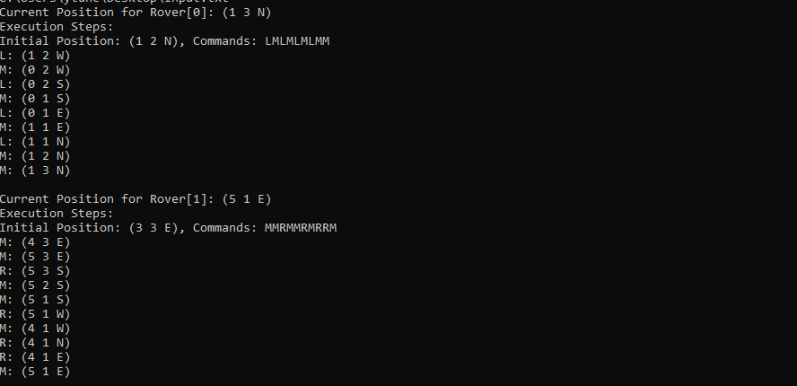

After file is read, for each rover starting at index 0, Current Position(final position after commands are executed), Initial position with commands and execution history history is printed out. For each command, command key and the next position is shown thereby it is easy to follow

Whenever a command makes next position be out of border (goes beyond the lower-left or upper-right coordinates) it is bypasses and the next command is executed

An example is given below. The second command M is not executed in order for the rover not to be out of border and *“Command bypassed due to crossing border”* message is given

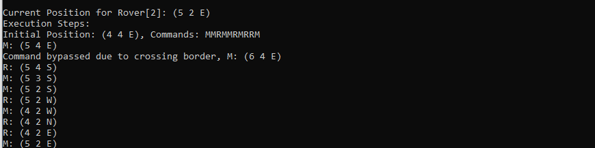

**Second Choice: R**

When key R is chosen, user is prompted to specify the inputs one by one

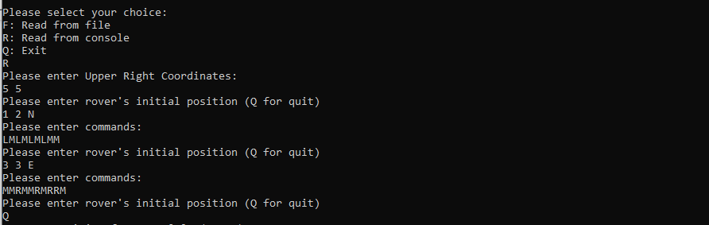

First input is for the upper right coordinates of plateau, then initial position and command for the rover is entered by the user until presses Q for quit.

After pressing Q for quit, all the information about the rovers is displayed as described in reading from file section.

